Student Name: Sahil Gupta UID: 25MCI10266
Branch: MCA(AI/ML) Section/Group: 25MAM-1 A
Semester: 2nd sem Date of Performance:12/01/2026
Subject Name: TECHINCAL SKILLS Subject Code:

WORKSHEET 5
AIM: To gain hands-on experience in creating and using cursors for row-by-row processing in a database, enabling sequential access and manipulation of query results for complex business logic. (Company Tags: Infosys, Wipro, TCS, Capgemini)
S/W Requirement: Oracle Database Express Edition and pgAdmin
OBJECTIVES:
- Sequential Data Access: To understand how to fetch rows one by one from a result set using cursor mechanisms.
- Row-Level Manipulation: To perform specific operations or calculations on individual records that require conditional procedural logic.
- Resource Management: To learn the lifecycle of a cursor: Declaring, Opening, Fetching, and importantly, Closing and Deallocating to manage system memory.
- Exception Handling: To handle cursor-related errors and performance considerations during large-scale data iteration.

Practical / Experiment Steps
Table creation
CREATE TABLE Employee (
emp_id SERIAL PRIMARY KEY,
emp_name VARCHAR(50),
salary NUMERIC(10,2),
experience INT,
performance_score INT
);
Inserting Sample Values
INSERT INTO Employee (emp_name, salary, experience, performance_score) VALUES
('Priya', 60000, 5, 8),
('Karan', 20000, 1, 5),
('Ranjit', 12000, 1, 4),
('Manvinder', 50000, 7, 7),
('Bahubali', 90000, 10, 9);

Output:
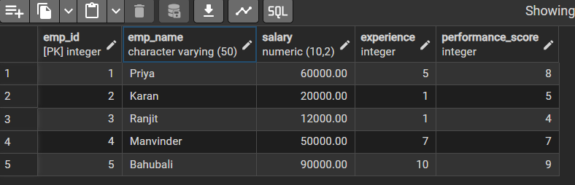

Step 1: Implementing a Simple Forward-Only Cursor
DO $$
DECLARE
emp_record RECORD; -- Variable to hold one row
emp_cursor CURSOR FOR -- Declare cursor
SELECT emp_id, emp_name, salary
FROM Employee;
BEGIN

OPEN emp_cursor; -- Open cursor

LOOP
FETCH emp_cursor INTO emp_record; -- Fetch one row

EXIT WHEN NOT FOUND; -- Exit when no more rows

RAISE NOTICE 'ID: %, Name: %, Salary: %',
emp_record.emp_id,
emp_record.emp_name,
emp_record.salary;
END LOOP;
CLOSE emp_cursor; -- Close cursor
END $$;
Output:
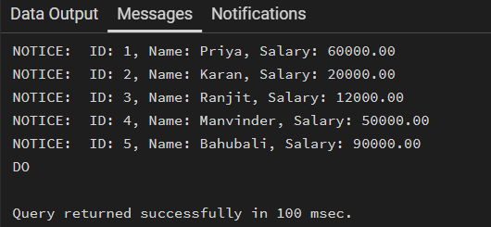

Step 2: Complex Row-by-Row Manipulation
DO $$
DECLARE
emp_record RECORD;
emp_cursor CURSOR FOR
SELECT emp_id, emp_name, salary, experience, performance_score
FROM Employee;

ratio NUMERIC;
new_salary NUMERIC;
BEGIN

OPEN emp_cursor;

LOOP
FETCH emp_cursor INTO emp_record;
EXIT WHEN NOT FOUND;

-- Prevent division by zero
IF emp_record.experience = 0 THEN
RAISE NOTICE 'Skipping % due to zero experience',
emp_record.emp_name;
CONTINUE;
END IF;

-- Calculate ratio
ratio := emp_record.performance_score::NUMERIC
/ emp_record.experience;

-- Apply business logic
IF ratio >= 1.5 THEN
new_salary := emp_record.salary * 1.20;
ELSIF ratio >= 1.0 THEN
new_salary := emp_record.salary * 1.10;
ELSIF ratio >= 0.5 THEN
new_salary := emp_record.salary * 1.05;
ELSE
new_salary := emp_record.salary;
END IF;

-- Update row
UPDATE Employee
SET salary = new_salary
WHERE emp_id = emp_record.emp_id;

RAISE NOTICE 'Updated % | Old: % | New: % | Ratio: %',
emp_record.emp_name,
emp_record.salary,
new_salary,
ratio;

END LOOP;
CLOSE emp_cursor;
END $$;
Output:
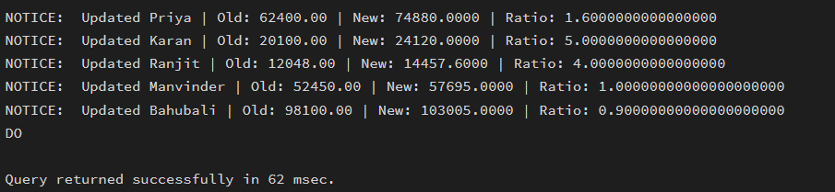

Step 3: Exception and Status Handling
DO $$
DECLARE
emp_record RECORD;
emp_cursor CURSOR FOR
SELECT emp_id, emp_name, salary, experience, performance_score
FROM Employee;

ratio NUMERIC;
new_salary NUMERIC;
row_count INT := 0;

BEGIN
OPEN emp_cursor;

LOOP
FETCH emp_cursor INTO emp_record;
EXIT WHEN NOT FOUND;

row_count := row_count + 1;

BEGIN
-- This will throw error if experience = 0
ratio := emp_record.performance_score::NUMERIC
/ emp_record.experience;

-- new_salary := 'abc'; -- error occurance
IF ratio >= 1.5 THEN
new_salary := emp_record.salary * 1.20;
ELSIF ratio >= 1.0 THEN
new_salary := emp_record.salary * 1.10;
ELSIF ratio >= 0.5 THEN
new_salary := emp_record.salary * 1.05;
ELSE
new_salary := emp_record.salary;
END IF;

UPDATE Employee
SET salary = new_salary
WHERE emp_id = emp_record.emp_id;

RAISE NOTICE 'Updated % successfully.',
emp_record.emp_name;

EXCEPTION
WHEN division_by_zero THEN
RAISE NOTICE '❌ Division by zero for employee: %',
emp_record.emp_name;

WHEN OTHERS THEN
RAISE NOTICE '⚠ Unexpected error for employee: %',
emp_record.emp_name;
END;

END LOOP;

CLOSE emp_cursor;

IF row_count = 0 THEN
RAISE NOTICE 'No employees found.';
ELSE
RAISE NOTICE 'Processing completed for % employees.',
row_count;
END IF;

EXCEPTION
WHEN OTHERS THEN
RAISE NOTICE '🚨 Fatal error occurred: %', SQLERRM;
END $$;

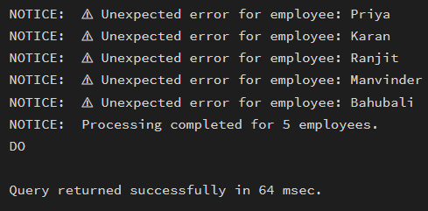
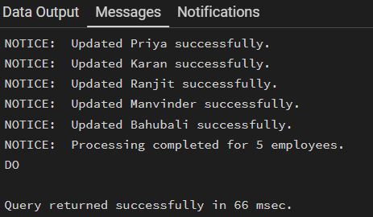
Output:

Outcomes:
- Cursor Implementation: Students will be able to design, implement, and manage cursors to solve row-wise processing problems.
- Lifecycle Mastery: Students will demonstrate the correct syntax for declaring, opening, fetching, and closing cursors.
- Error Prevention: Students will understand how to properly handle row-by-row processing exceptions and prevent memory leaks via deallocation.
- Analytical Thinking: Students will be able to apply cursor-based logic to solve real-world scenarios like multi-level payroll adjustments or data migrations.

